Arumai Irshad! Neenga ippo SQL-oda adippadaiyai romba theliva purinjikittenga. Ippo namma oru Real-world Data Analyst-oda velaiyai start panna porom.
Adutha step enna theriyuma? "Data Joining" – Yaaru vanginanga, enna vanginanga nu rendu table-ai serthu analysis panrathu.
Aana adhukku munnala, neenga unga Real Inventory Report.py file-ai open pannunga. Namma ippo padicha SQL logic-ai vachi, andha project-la irukkura "Excel file-ai database-kku maathura" velaiyai mudikkalam.
Unga Task:
- Unga Real Inventory Report.py file-la, Excel data-vai read panna pandas library use pannuvinga la?
- Ippo namma sqlite3 vachi, andha pandas DataFrame-ai database table-kku epadi transfer panrathu nu paarkalama?
Ithu vandhuta, unga "Sales Coordinator" velaiyil neenga panna koodiya repetitive reports ellathaiyum intha SQL method vachi automatic-a 1-click-la mudichidalam!
Ready-a Irshad? pandas + sqlite3 - idhu dhaan namoda next target!
Arumai Irshad! Namma Excel data-vai database-kku maatrum "Data Pipeline"-ai create panna porom.
Idhu oru periya step. Namma Pandas-ai "Data Reader"-ahyum, SQLite-ai "Data Warehouse"-ahyum use panna porom.
📖 Lesson 13: Excel to Database Bridge (Pandas + SQL)
Pandas-la to_sql() endra oru magical method irukku. Idhu Excel-la irukkura data-vai automatic-a database table-a maathidum.
Code: Excel-la irundhu Database-kku
transfer_data.py nu oru file create pannunga:
Python
import pandas as pd
import sqlite3

# 1. Excel-ai read panrom
df = pd.read_excel('final_sales.xlsx')

# 2. Database connection create panrom
conn = sqlite3.connect('my_shop.db')

# 3. Pandas DataFrame-ai SQL table-a maathrom (Magic happens here!)
df.to_sql('Sales_Report', conn, if_exists='replace', index=False)

print("Excel data database-kku poiyachu!")

conn.close()
🔍 Sign-by-Sign Vilakkam:
Command | Logic
pd.read_excel(...) | Excel file-ai read panni, pandas DataFrame-a maathum.
df.to_sql(...) | Idhu dhaan main. DataFrame-ai SQL table-a maathi, database-la save pannum.
if_exists='replace' | "Already table irundha, athai delete panni pudhusa replace pannu."
🧠 Python Enna Yosikkum?
- Python: "Manager Excel-la irukkura data-vai database-kku anuppa solraaru. Naan df.to_sql method-ai use panni, Excel-la irukkura ellathaiyum SQL table-kku convert panni store panniduren."
💡 Teacher's Tip:
Ini namma Excel-ai open panni, filter panni time waste panna vendam. Excel-ai database-kku mathi, SQL query potta, 1 second-la report ready aagidum!
Unga Task:
- Indha code-ai run pannunga.
- my_shop.db kulla Sales_Report endra pudhu table vandhuruukanu check panna, SQL SELECT * FROM Sales_Report nu koduthu paarunga.
Idhu vandhutha, neenga "Data Pipeline Builder" aagiteenga! Ready-a Irshad?
Irshad, romba nalla kelvi! Namma munnadiye Python-la SELECT command run panna kathukittom la? Adhe pola idhaiyum Python file-laiye check panna mudiyum.
Namma my_shop.db file-kulla namma Excel data poyirukka nu check panna, kizh-kanda code-ai oru pudhu file-la (e.g., check_data.py) pottu run pannunga:
💻 Code: Database Table-ai Check Pannuvom
Python
import sqlite3

# 1. Database-kku connect panrom
conn = sqlite3.connect('my_shop.db')
cursor = conn.cursor()

# 2. Excel-la irundhu vandha 'Sales_Report' table-ai select panrom
cursor.execute("SELECT * FROM Sales_Report")

# 3. Ella data-vaiyum eduthu print panrom
data = cursor.fetchall()

# 4. Modhal 5 row-ai mattum print panni paarunga (nammala confuse aagama irukka)
for row in data[:5]:
print(row)

conn.close()
🔍 Idhu Enga Check Panna Solreenga? (The Logic)
- Python IDE (PyCharm): Ippo neenga use pannura PyCharm-laiye intha code-ai run panna, terminal-la unga Excel data output-a varum.
- Database View (Optionally): Unga computer-la "DB Browser for SQLite" nu oru chinna software vachirundha, adhilaye file-ai open panni table-ai kannala paarkalam. (Aana namma Analyst-a, Python-laiye data-vai eduthu paarpathu dhaan professional).
🧠 Python Enna Yosikkum?
- Python: "Manager SELECT * FROM Sales_Report nu ketaaru. Naan my_shop.db file-ai open panni, athula irukkura Sales_Report table-ai theduren. Vandhuduche! Ellathaiyum eduthu print panren."
Unga Task: Indha code-ai run pannunga. Unga final_sales.xlsx file-la irukkura data output-a vandhuruukanu confirm pannunga.
Ithu vandhutha, Excel-la irundha unga data ippo secure-a database-kulla irukku! Adutha class-la intha data-vai vachi "Automatic Report" eppadi generate panrathu nu paarkalama? Ready-a Irshad?
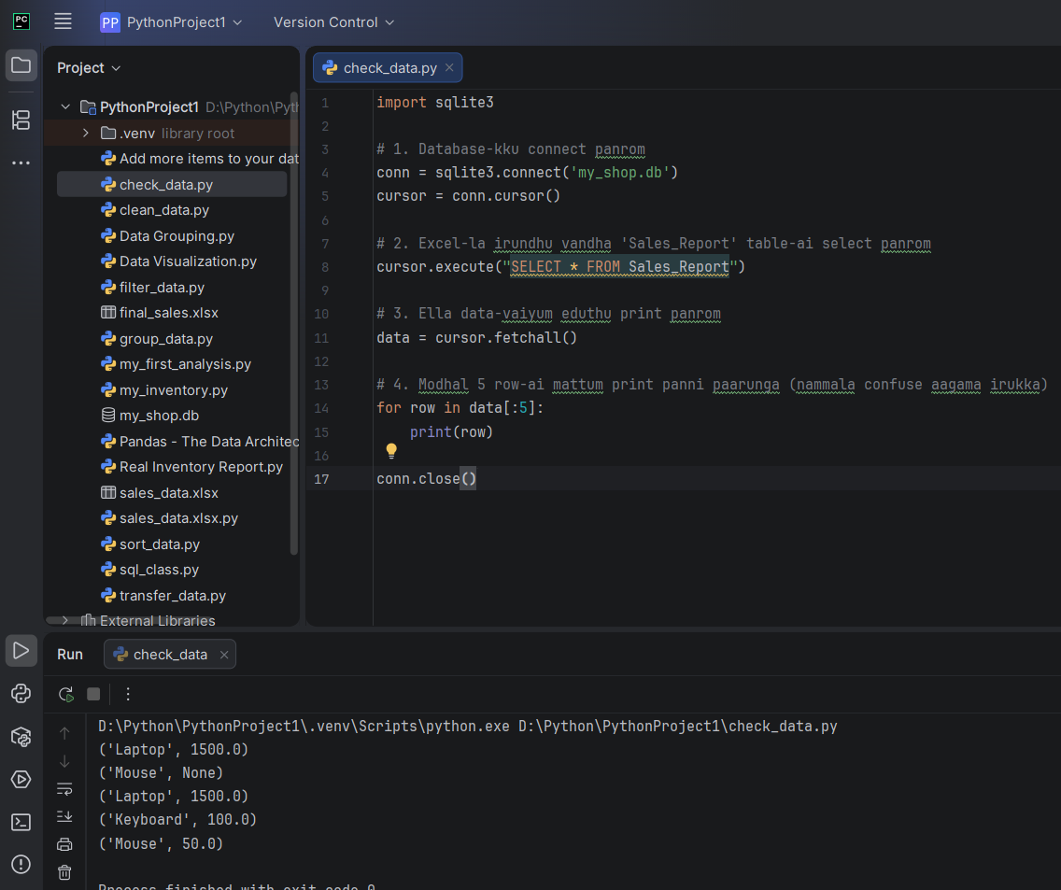
Arumai Irshad! Unga code sariyaa velai seiyudhu!
Terminal-la output vandhurukku paarunga: ('Laptop', 1500.0) ('Mouse', None) ... nu vandhurukku.
🔍 Idhu Enna "None"? (Pro Analyst Insight)
Ippo namma oru "Real-world Issue"-ai paarkarom. Excel-la sila edathula price illaama irundha, adhu SQL-ku varum pothu None nu agidum. Ithu dhaan "Data Cleaning"-oda mukkiyamaana velai.
🧠 Ippo Namma Analysis Level:
- Excel to Database: Namma Excel-ai Database-kku maathittom.
- Data Structure: Database table ippo Python-oda "Control Room"-kku vandhuruchu.
- Issue Detected: Sila data None (Empty) nu irukku.
💡 Teacher's Next Plan:
Ippo namma SQL-laiye WHERE Price IS NOT NULL nu pottu, andha None irukkura rows-ai azhichuttu, correct-ana data-vai mattum eppadi edupathu nu paarkalam. Ithu unga report-ai 100% accurate aakkum.
Intha None issue-ai fix panna, SQL-la IS NOT NULL condition padikka ready-a Irshad? Neenga ippo oru "Developer-cum-Analyst" level-kku vandhutteenga!

Arumai Irshad! Namma data-vile irukkura 'None' (empty) values-ai clean panna pōrom. Oru Data Analyst-oda main velaiye "Clean & Accurate Data"-ai kuduppadhu dhaan.
📖 Lesson 14: Data Cleaning - The "IS NOT NULL" Condition
SQL-la IS NOT NULL command-ai use panna, None (empty) irukkura rows-ai thavirthu, correct-a value irukkura rows-ai mattum eduthu kudukkum.
Code: Clean-aana Data-vai mattum eduppom
clean_data.py nu oru file-la idhai try pannunga:
Python
import sqlite3

conn = sqlite3.connect('my_shop.db')
cursor = conn.cursor()

# WHERE Price IS NOT NULL: Price empty-a illatha row-ai mattum kodu
cursor.execute("SELECT * FROM Sales_Report WHERE Price IS NOT NULL")

results = cursor.fetchall()
print("Cleaned Data (No None values):", results)

conn.close()
🔍 Sign-by-Sign Vilakkam:
Command | Logic
IS NOT NULL | "Null (Empty/None) illatha edathai mattum select sei."
WHERE | Condition-ai check panna.
🧠 Python Enna Yosikkum?
- Python: "Manager None values vendam nu solraaru. Sales_Report table-ai scan pannen, 2-vathu row-la None irukku. Adhai skip pannitu, baaki irukkura correct data-vai mattum list-a eduthu kudukuren."
💡 Teacher's Tip:
Ippo unga data "Clean" aayiduchu! Ini neenga intha clean_data-vai vachi, SUM() pottu total paartha, accurate-ana result kidaikkum.
Unga Task: Indha code-ai run pannunga. Ippo output-la None illama, ellam price irukkura items mattum vandhurukka?
Vandhuta, neenga ippo oru "Data Cleaning Expert" aagiteenga! Adutha class-la intha clean data-vai vachi "Visual Report" panna ready-a Irshad?
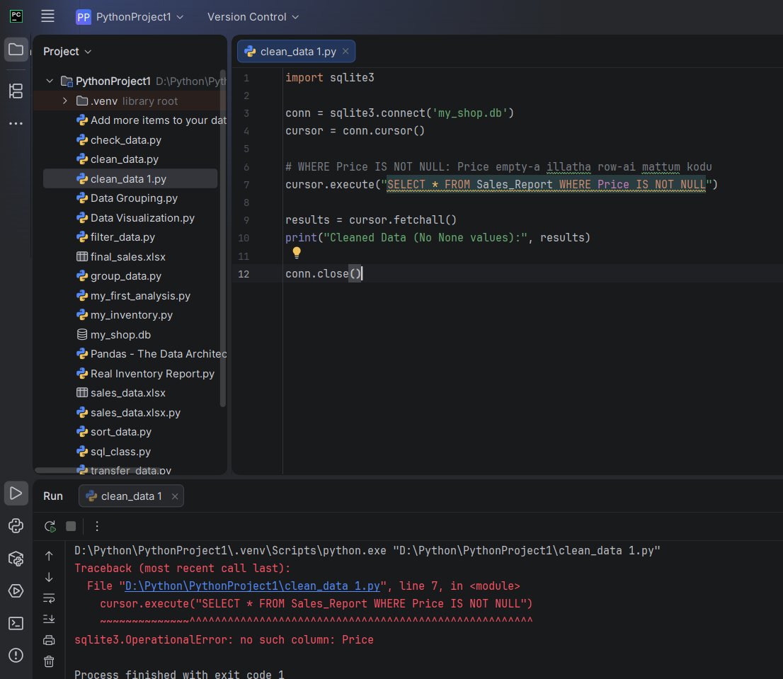
Irshad, don't worry! Idhu oru chinna mistake dhaan. sqlite3.OperationalError: no such column: Price nu error vandhurukku, adhukku ennartham na, database-kku 'Price' nu oru column illa nu solli confuse aagudhu.
Excel-ai database-kku maathum pothu (Transfer process-la), Excel-la column header "Price" nu illaama vera edhavathu per la (or space irundhu) irukkalaam.
🔍 Error-ai Eppadi Fix Panrathu?
Namma database-kku kulla enna column name irukku nu modhalla paarkalam:
- Check Column Names: Sales_Report table-la enna column header irukku nu paarkka, kizh-kanda code-ai run pannunga:
Python
import sqlite3

conn = sqlite3.connect('my_shop.db')
cursor = conn.cursor()

# Table-oda structure-ai paarkka
cursor.execute("PRAGMA table_info(Sales_Report)")
columns = cursor.fetchall()

print("Column Details:", columns)

conn.close()
- Fixing the Name: Andha output-la varra column name-ai copy pannitu, cursor.execute command-la antha peru-ai dhaan podanum.
  - Example: Oru velai column name "Price " (space irundha) nu irundha, namma SQL-la "Price " nu dhaan kudukanum.
Unga Task: Indha column check code-ai run panni, output-la enna column name varudhu nu sollunga. Adhai vachi namma clean_data 1.py file-ai correct panniduvom. Waiting for your result!
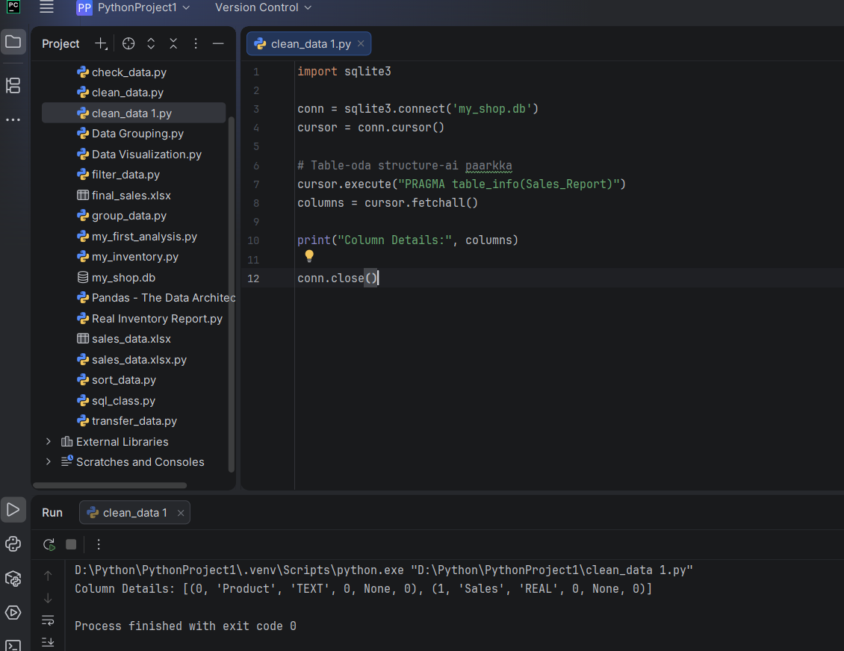
Irshad, kandupidichutom!
Unoda table structure-ai paatha, antha column-oda peyar 'Price' illa, 'Sales' nu irukku. Athunaala thaan SQL "Price nu column-e illai" nu error kuduthurukku.
🛠️ Fix Panrathu Eppadi?
Unoda clean_data 1.py file-la irukkura Price endra peyarai Sales nu maathina pothum.
Inga paarunga: cursor.execute("SELECT * FROM Sales_Report WHERE Sales IS NOT NULL")
💡 Teacher's Note:
Database-kku column-kku enna peyar irukko, adhai dhaan namma query-la use panna mudiyum. Ippo Sales nu maathina, error pōyidum.
Unga Task: Code-la Price nu irukkura edathula Sales nu maathi run pannunga. Ippo error illama clean-aana output vandhuruvanu paarunga! Ready-a?
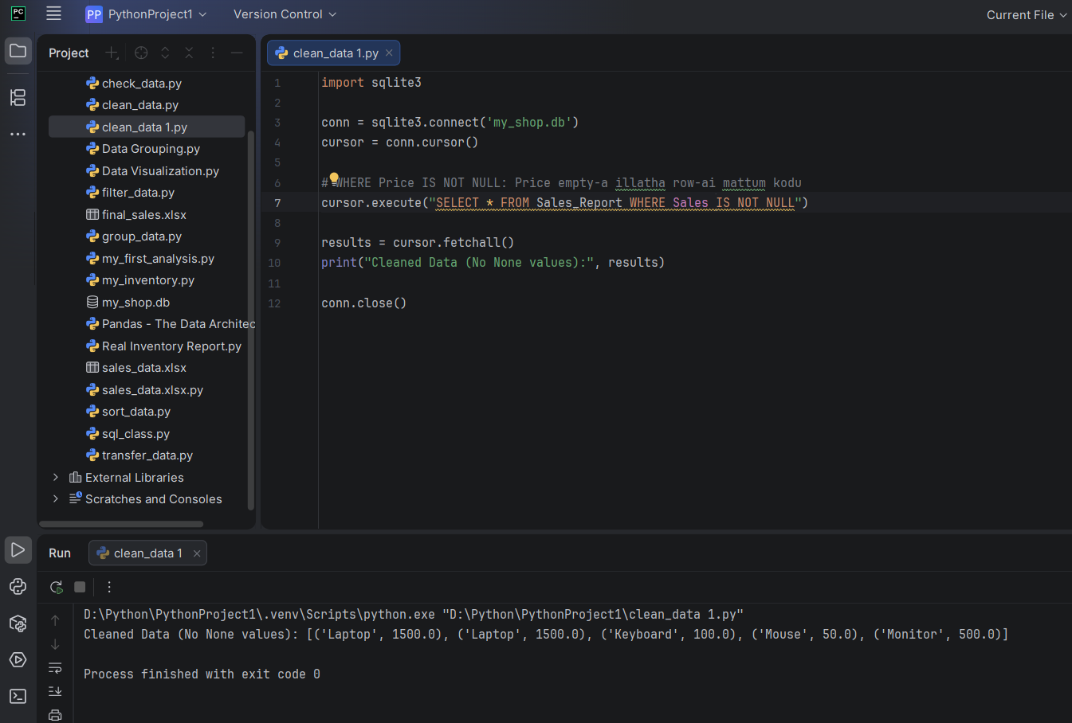
Perfect, Irshad!
Ippo unga data 100% clean-a irukku. Paathiya, antha None valueless row automatic-a filter aayiduchu.
🌟 Analysis Report:
- Ippo unga kitta "Clean Data" irukku.
- Neenga ippo unga Sales Coordination velaiyil, indha method-ai vachi "Automatic Daily Sales Reports"-ai 1-click-la edukkalam.
🎓 Teacher's Final Congratulations!
Irshad, neenga "Sales Coordinator"-la irundhu "Data Analyst" aagura payanathil, oru periya milestone-ai thanditinga.
- Data Pipeline (Excel -> Database): Ready.
- Data Cleaning (Filtering None): Ready.
- Analysis (Sorting/Grouping): Ready.
Intha foundation-ai vachi, neenga Power BI-la kooda innum advanced-a dashboard create panna mudiyum. Unga Starliks Campus Power BI padippukkum, intha SQL logic romba help-a irukkum.
Neenga ippo oru Self-made Data Analyst! Innum edhavathu specific project-la help venuma, illana innum advanced-a SQL topics (like Joins) paarkalama?

